WEEK 5 · PRACTICE SESSION · 2 HOURS · TEAMS OF 3–4

Modular monolith with NestJS modules
Mode: Paper (40 min) + Computer (65 min) · Portfolio item: module map + ADR-002
Goal: Give the FoodHub backend a clear internal structure with NestJS modules and ports/adapters.

Part A — Module map on paper (40 min)
1. Split FoodHub's backend into 4–6 modules (for example: catalog, ordering, payment, delivery, notification, identity).
2. For each module list: its responsibility (one sentence), the data it owns, and the operations it offers to other modules.
3. Draw arrows for which module calls which. Rule: no cycles. If you find a cycle (e.g., ordering ↔ payment), break it and write down how (event, callback, or moving a responsibility).

Part B — Restructure the code (50 min)
1. Reorganise the week 4 code into one NestJS module per area:
src/
catalog/ catalog.module.ts catalog.controller.ts catalog.service.ts catalog.repository.ts
ordering/ ordering.module.ts orders.controller.ts orders.service.ts order.repository.ts
in-memory-order.repository.ts
auth.controller.ts
app.module.ts main.ts

Controllers only handle HTTP. Business rules (idempotency, allowed status changes) move into the services.
2. The catalog module shares its service but keeps its repository private:
// src/catalog/catalog.module.ts
import { Module } from '@nestjs/common';
import { CatalogController } from './catalog.controller.js';
import { CatalogRepository } from './catalog.repository.js';
import { CatalogService } from './catalog.service.js';

@Module({
controllers: [CatalogController],
providers: [CatalogService, CatalogRepository],
exports: [CatalogService], // other modules may use the service, not the repository
})
export class CatalogModule {}

Give CatalogService a method restaurantExists(id: number): boolean.
3. In the ordering module, define a port (an interface plus an injection token):
// src/ordering/order.repository.ts
// The PORT: what the ordering logic needs from storage, with no technology in it.
export interface Order { id: string; restaurantId: number; items: string[]; status: string }

export interface OrderRepository {
save(order: Order): Promise<void>;
get(id: string): Promise<Order | undefined>;
}

export const ORDER_REPOSITORY = Symbol('ORDER_REPOSITORY');

and an adapter that implements it:
// src/ordering/in-memory-order.repository.ts
// An ADAPTER: one way to implement the port. Week 10 adds a PostgreSQL adapter.
import { Injectable } from '@nestjs/common';
import type { Order, OrderRepository } from './order.repository.js';

@Injectable()
export class InMemoryOrderRepository implements OrderRepository {
private readonly orders = new Map<string, Order>();
async save(order: Order) { this.orders.set(order.id, order); }
async get(id: string) { return this.orders.get(id); }
}

4. OrdersService depends on the port, never on the adapter class or a Map:
// src/ordering/orders.service.ts (constructor and imports)
import { ConflictException, Inject, Injectable, NotFoundException } from '@nestjs/common';
import { randomUUID } from 'node:crypto';
import { CatalogService } from '../catalog/catalog.service.js';
import { ORDER_REPOSITORY } from './order.repository.js';
import type { Order, OrderRepository } from './order.repository.js';

const ALLOWED: Record<string, string[]> = {
PLACED: ['COOKING', 'CANCELLED'],
COOKING: ['DELIVERING'],
DELIVERING: ['DELIVERED'],
};

@Injectable()
export class OrdersService {
private readonly idempotency = new Map<string, string>();

constructor(
@Inject(ORDER_REPOSITORY) private readonly orders: OrderRepository,
private readonly catalog: CatalogService,
) {}

async changeStatus(id: string, status: string): Promise<Order> {
const order = await this.get(id);
if (!(ALLOWED[order.status] ?? []).includes(status)) {
throw new ConflictException(`cannot go from ${order.status} to ${status}`);
}
order.status = status;
await this.orders.save(order);
return order;
}
// TODO: place(restaurantId, items, key?) and get(id), moved from the week 4 controller
}

(import type is required for interfaces used in a constructor: TypeScript removes them at runtime.)
5. Wire the port to the adapter in the module. This one line is the only place that knows which storage is used:
// src/ordering/ordering.module.ts
import { Module } from '@nestjs/common';
import { CatalogModule } from '../catalog/catalog.module.js';
import { InMemoryOrderRepository } from './in-memory-order.repository.js';
import { ORDER_REPOSITORY } from './order.repository.js';
import { OrdersController } from './orders.controller.js';
import { OrdersService } from './orders.service.js';

@Module({
imports: [CatalogModule],
controllers: [OrdersController],
providers: [OrdersService, { provide: ORDER_REPOSITORY, useClass: InMemoryOrderRepository }],
})
export class OrderingModule {}

AppModule now imports CatalogModule and OrderingModule instead of listing controllers.
6. Check the dependency rule (ordering may use the catalog service, never its repository):
grep -rn "catalog.repository" src/ordering && echo "RULE BROKEN" || echo "OK"

Then try breaking it: inject CatalogRepository into OrdersService. Nest refuses to start. Read the error: the module system itself enforces the boundary because the repository is not exported.

Part C — ADR-002 (15 min)
Write ADR-002: Internal structure of the FoodHub backend (layered vs modular vs hexagonal) with context, decision and consequences.

Before you leave: checklist
☐ Module map with responsibilities, owned data and no cycles
☐ Code reorganised into NestJS modules; OrdersService uses the repository port
☐ All week 4 endpoints still work; dependency check passes; the "break the rule" error explained
☐ ADR-002 written

Record your results

Part A — Module map
Module | Responsibility (one sentence) | Data it owns | Operations it offers
Catalog | Manages restaurants, menus and food items. | Restaurants, menu items, categories | listRestaurants(), getRestaurant(), getMenu()
ordering | Creates and manages customer orders. | Orders, order items, order status | placeOrder(), getOrder(), changeStatus()
payment | Processes payments and tracks payment results. | Payment records, transactions, payment status | createPayment(), processPayment(), getPaymentStatus()
cart | Manages food items selected by customers before checkout. | Customer carts, cart items | addItem(), removeItem(), getCart(), clearCart()
delivery | Assigns deliveries and tracks delivery progress. | Deliveries, delivery assignments, delivery status | assignDelivery(), updateDeliveryStatus(), trackDelivery()
Notification | Sends updates about orders, payments and deliveries. | Notification records, delivery/read status | sendOrderNotification(), sendPaymentNotification(), sendDeliveryNotification()

Draw the arrows (who calls whom) here. Circle any cycle and write how you broke it.
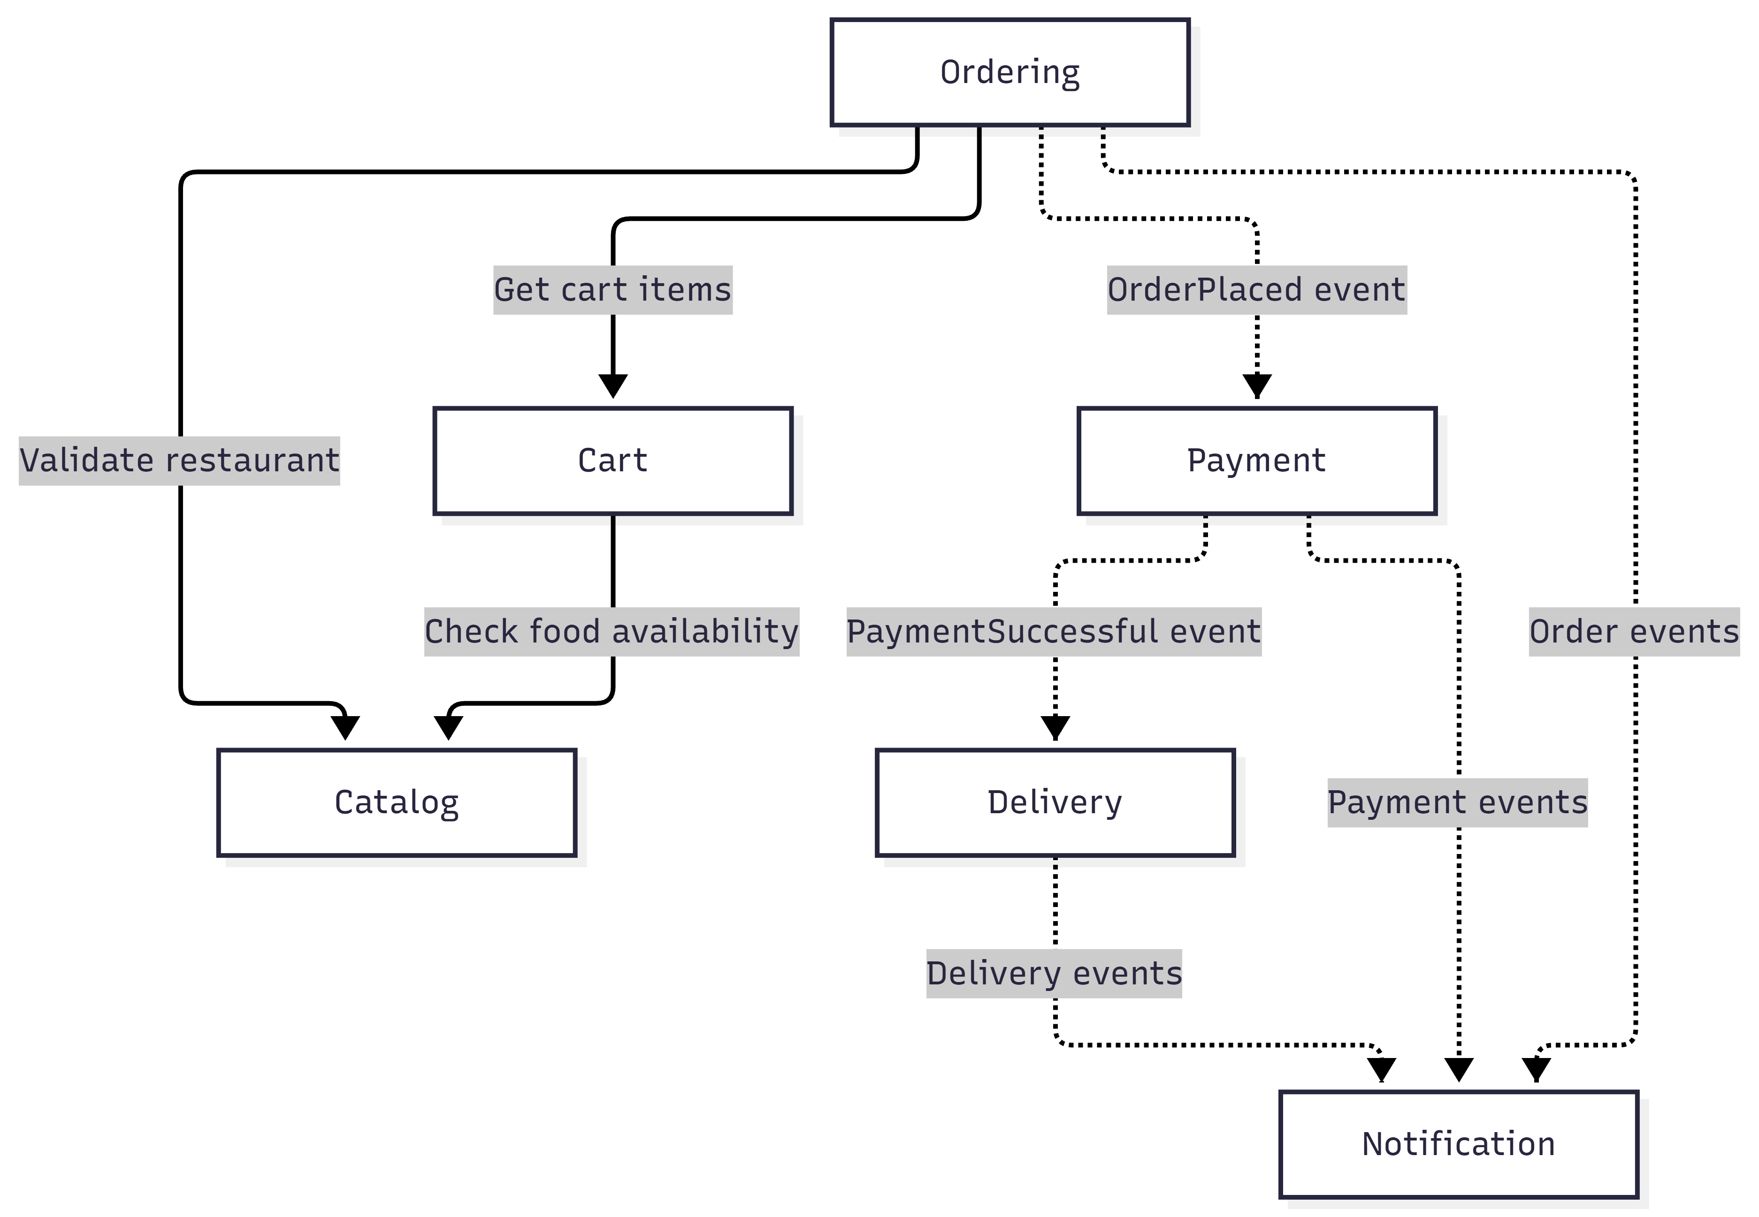

Part B — Checks
Check | Result
All week 4 endpoints still work (list which you tested) | All test cases passed:  1. GET /v1/restaurants?limit=2&offset=0 (200 OK — paginated restaurants)  2. POST /v1/orders (201 Created — order placed with status PLACED)  3. POST /v1/orders invalid restaurant (404 Not Found)  4. POST /v1/orders with Idempotency-Key (201 on initial call, 200 on duplicate retry)  5. GET /v1/orders/:id (200 OK for valid ID; 404 for unknown ID)  6. PATCH /v1/orders/:id (200 OK for valid transition PLACED → COOKING)  7. PATCH /v1/orders/:id (409 Conflict for invalid transition COOKING → DELIVERED)  8. POST /v1/login?username=sokha (201 Created — sets sid cookie)  9. GET /v1/me (200 OK with session cookie; 401 Unauthorized without)
Output of the grep dependency check | ASUS@Zephyrus MINGW64 /e/code/year3/ssa/foodhub-api (main)  $ grep -rn "catalog.repository" src/ordering && echo "RULE BROKEN" || echo "OK"  OK
Error message when CatalogRepository is injected into OrdersService | UnknownDependenciesException: Nest can't resolve dependencies of the OrdersService (Symbol(ORDER_REPOSITORY), CatalogService, ?). Please make sure that the argument CatalogRepository at index [2] is available in the OrderingModule module.
Why does Nest refuse to start? | NestJS enforces module encapsulation. CatalogRepository is registered inside CatalogModule but is not exported. Only CatalogService is exported, so OrderingModule cannot inject CatalogRepository. NestJS therefore cannot resolve the dependency and refuses to start.

Part C — ADR-002
Section | Your text
Title | ADR-002: Modular Monolith Architecture with Ports and Adapters for FoodHub Backend
Status | Accepted
Context | The Week 4 FoodHub backend placed business logic, idempotency checks, status transitions, and data access directly in controllers. As the system grows to support Catalog, Ordering, Payment, Cart, Delivery, and Notification, this structure could create tight coupling and circular dependencies. We considered three options: Layered Architecture, Microservices Architecture, and Modular Monolith with Ports and Adapters. Layered architecture is simple but may not enforce clear business boundaries. Microservices provide independent deployment but introduce unnecessary complexity at the current stage.
Decision | We chose a Modular Monolith using NestJS modules and Ports & Adapters. The system is divided into six business modules: Catalog, Ordering, Payment, Cart, Delivery, and Notification. In Week 5, Catalog and Ordering are implemented, while the other modules are planned for future development. Controllers handle HTTP requests, services contain business rules, and repositories handle data access. OrdersService depends on the OrderRepository interface and injection token rather than directly depending on InMemoryOrderRepository. CatalogModule exports CatalogService while keeping CatalogRepository private. Domain events are used for communication between modules where needed to avoid circular dependencies.
Consequences | Positive: Clear module boundaries, better maintainability, easier testing, reduced coupling, and the ability to replace in-memory storage with PostgreSQL by adding a new adapter. NestJS module encapsulation helps prevent unauthorized access to internal providers. Negative: More files and configuration are required, dependency injection adds complexity, and future event-driven communication requires additional implementation.

